Lead college coordination committee
Year 2018-19/workshop-01

Title of the programme: - “Preparation of Youth Festival”
Chief Guest: - Dr. R.V Gurav (director, student welfare,
Shivaji university, Kolhapur), Milind sandi,
Swstik Mali, Swpnil Yadav,Abhijit Patil
(Well-known Artists)
President: - Dr. Vijaya Chavan (Principal,VYMP)

Venue: - Auditorium Hall, VYMP, Pethvadgaon
Date and time : 21st August 2018 /9.00am to 4.30pm
Beneficiaries/Target group: - Graduate level artist’s students of cluster colleges

Corresponding CO’s covered: - ….

Name of convener:- Dr.R.H.Atigre (Chairman, Cultural committee )

Details Report:-
The workshop is basically based on the theme of youth festival activities of Shivaji University, Kolhapur. The chief guest has given information and rules of youth festivals of Shivaji University and above stages. He express, the role of students must be developing through the cultural activities. The cultural skills have real potential in the field of drama and films. The music, acting, art are not only gives us money but also these are develop our personality.
The other guests such as Milind Sandi, Abhijit Patil, and Swastik Mali are given guidance through the practices of various arts. The participants very actively involved in these activities. Dr. Vijaya Chavan (principal, VYMP) was the president of this workshop. She expressed that; Youth festivals is not part of only enjoy but it is door of opportunity. Dr. Atigre R.H mentions vote of thanks.

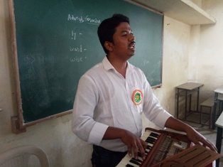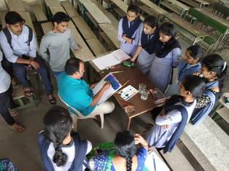
(Abhijit Patil, Well known Artist) (Milind Sandi, Well known Artist)

Dr. Atigre R.H. Dr. Nisargandh P.R.

