Lead college
workshop-01

Title of the Programme: “Science consciousness: An Indispensable”
Chief Guest: Dr.Ashok Patil (Shahu College, Rukadi), Dr. T.S. Chougule, Dr.Salve S.G. (KRP kanya collge,Islamapur), Jagtap D.G(VYMP)
President: Nikam A.H. (Principal,VYMP)
Venue: Auditorium Hall, VYMP, Pethvadgaon
Date and time : 22nd September 2017/9.00am to 4.30pm
Beneficiaries/Target group: Graduate level artist’s students of cluster colleges
Name of convener:- Dr.M.A.Patil (Chairman,Vivek Vahini Samitee)

The workshop was classified in to three sessions. The first session was the opening session. The Prof. Jagatap D.J. inaugurated this function. He said scientific view must be accepted by students for their future.
The first session handled by Dr.Ashok Patil as a chef guest. He has given demo to prove scientific perspectives. He explained the how the superstation will be destroyed through the scientific activities. He expressed the role students to destroy the superstations in the Indian society.
The second session was organized for the student’s activities. A group discussion, presentation, poster display, Drama etc. activities has been done by the students. Dr.Salve S.G. has supervised this session. T.S.Chougule was the speaker of last session. He explained the role of science in our daily life through various examples. He expressed that we should to aware about the anti human activities of industrial products.
Nikam A.H. (Principal, VYMP) was the president of this workshop. Dr.M.A.Patil mentions vote of thanks.

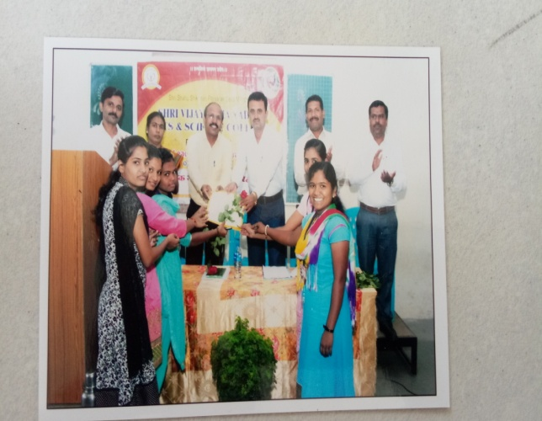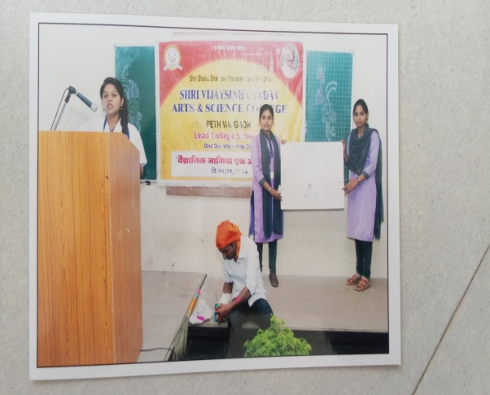

Dr.M.A.Patil Dr. Nisargandh P.R.

