Lead college
workshop-02

Title of the programme: “Opportunities in Languages”
Chief Guest: Dr.Nandkumar More, Dr. Milind Desai, and Dr. Arjun Chavan (Shivaji University, Kolhapur)
President: Nikam A.H. (Principal,VYMP)
Venue: - Auditorium Hall, VYMP, Pethvadgaon
Date and time:- 19th September 2018/9.00am to 4.30pm
Beneficiaries/Target group: Graduate students of cluster colleges
Name of Convener: Patil S.P. (HOD, English Department)

The workshop was organized for the students of languages especially for the students of Marathi, Hindi and English departments. Dr.Nandkumar More was the speaker of first session of this workshop. He has given the opportunities in the languages especially for the students of Marathi. He said, the role of ICT is become important for the new job of Marathi students.
Dr.Milind Desai was the speaker for the second session of the workshop. He has given importance of global language means English for the opportunities for the students. He said the most of peoples used English word in their daily life. It means English is not heard language to learn rather than special efforts. The expressed the whole world follow this language there for we must acquired this language in global age.
The eminent author Dr.Arjun Chavan has given speech in last session on the opportunities in Hindi language. He has given number of opportunities in the national language. He expressed that the Excellency is only way to acquired job in any field.
Nikam.A.H. (Principal, VYMP) was the president of this workshop..S.P.Patil mentions vote of thanks.
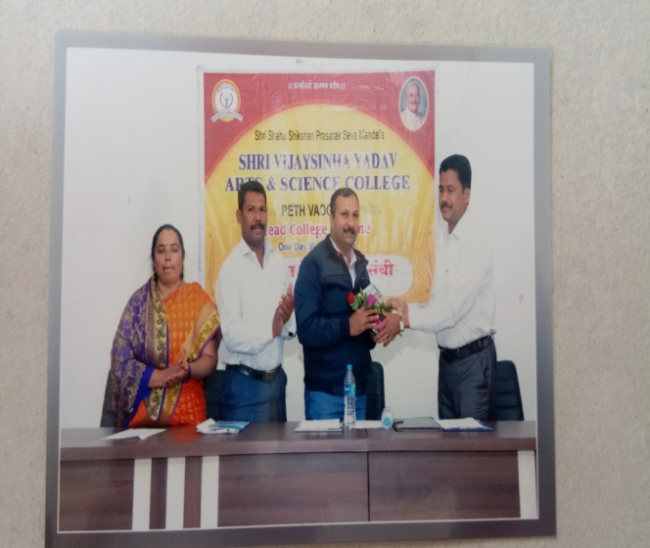

Dr.C.B.Mane Dr. Nisargandh P.R.

