Lead college coordination committee
Year 2017-18/workshop-02

Title of the programme: “Social Science Challenges and Opportunities”
Chief Guest: - Dr.H.N. Katre ( Dept.of Economics ,Rajaram college,
Kolhapur), Arvind Ghodke (Dept. of sociology ,
New college, Kolhapur) Dr. Saikh N.I. (VYMP))
President: - Nikam A.H. (Principal,VYMP)

Venue: - Auditorium Hall, VYMP, Pethvadgaon
Date and time:- 28th February 2018/9.00am to 4.30pm
Beneficiaries/Target group: Graduate students of cluster colleges especially for social science.
Corresponding CO’s covered: - ….
Name of Convener: Bhandare D.J. (Chairman Social Science Committee)
Details Report:-
The workshop was organized for the student for the students of social sciences. The workshop was divided into three sessions. The first session was on the challenges in fronts of social science students concern to the job opportunities. Dr. Kathre H.N. was the speaker of first session. He mentioned traditional and modern challenges in front of social science. He has given ways to solve these problems. He said without the development and participant of social science any society can’t solve their problems.
The second session was for the students activities. The poster presentation and group discussion were the main activates in this session.
Arvind Ghodke was the main speaker in the last session. He has given number of opportunities for the students through P.P.T. Presentation. He has given job opportunities on various levels such as: the Governmental, non-governmental, international, national, local etc. He has given concentration on norms, skills and extra activity for the job opportunity.

Nikam.A.H. (Principal, VYMP) was the president of this workshop..S.P.Patil mentions vote of thanks.

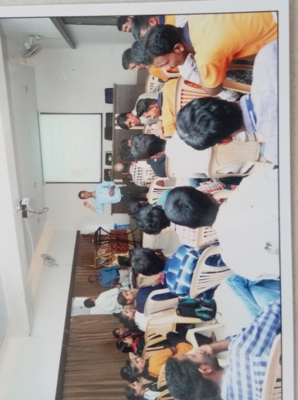

Dr.C.B.Mane Dr. Nisargandh P.R.

