Shri Vijaysinha Yadav Arts And Science College, Peth Vadgaon
Department of Sports
Report - 2016-2017
1) | Shubham Shivaji Sutar, B.A-I Selected in Shivaji University Hockey Team. | 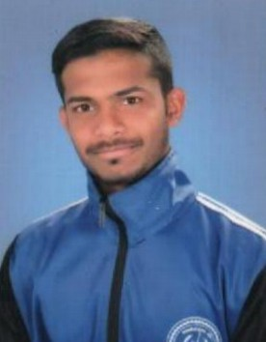
2) | Saurabh Bhimrao Sutar, B.A-I Selected in Shivaji University Hockey Team. | 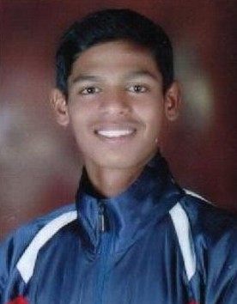
3) | Rohan Rajaram Powar, B.A-I Selected in Shivaji University Hockey Team. | 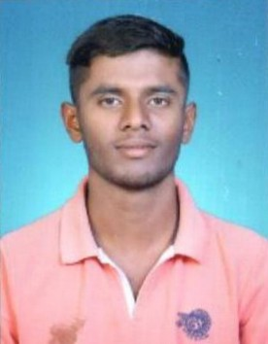
4) | Omkar Rajendra Kaware, B.A-I Selected in Shivaji University Hockey Team. | 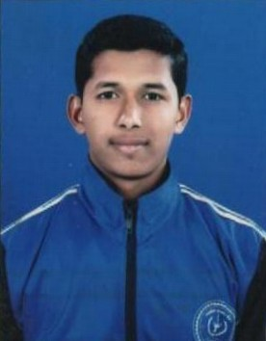
5) | Miss. Snehal Popatrao Wakse, B.Sc.-I got selected in Shivaji University Women Hockey team for All India inter University Hockey competition. | 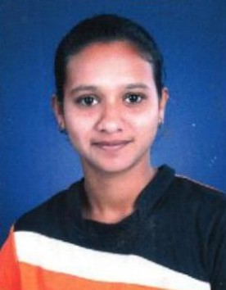
6) | Miss. Poonam Vishwas Gavad, B.Sc.-I got selected in Shivaji University Women Hockey team for All India inter University Hockey competition. | 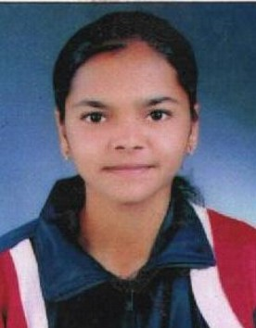
7) | Miss. Vidula Milind Patil, B.Sc.-I got selected in Shivaji University Women Hockey team for All India inter University Hockey competition. | 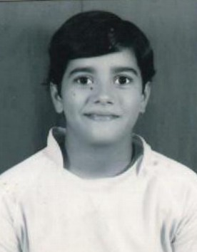
8) | Miss. Pooja Gajanan Shelkae, B.A.-I got selected in Shivaji University Women Kho-Kho team and got Silver Medal in all India Inter University Competition. | 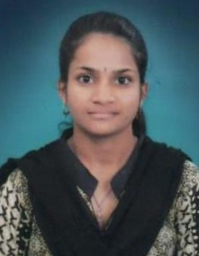
9) | Miss. Shubhada Shridhar Chougale, B.A.-III got selected in Shivaji University Dise throw team. | 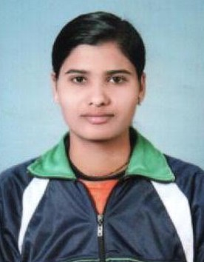
10) | Sanket Ramchandra Langarkar, B.A.-II got selected in Shivaji University Best Physic team men participation in All India inter University Competition. | 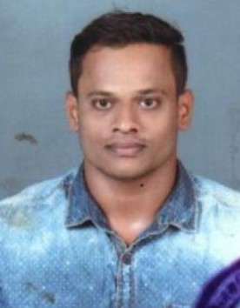
11) | Abhijeet Ravindra Wadkar, B.Sc.-I selected in Shivaji University Archery team and participated in all India Inter University Archery Competition. | 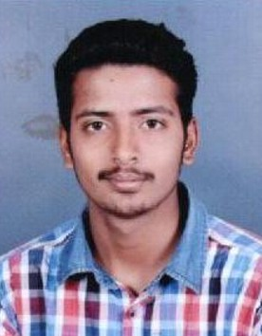
12) | Vivek Manohar Parit, B.Sc.-I selected in Shivaji University Archery team and participated in all India Inter University Archery Competition. | 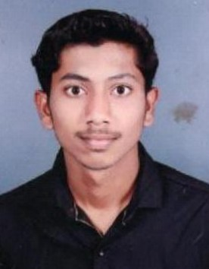
13) | Amol Sarjerao Mane, B.A.-II participated in Hammer throw compettion of Shivaji University Inter zonal competition and got Bronz Medal, and got Bronz Medal in inter zonal Best Physic competition. | 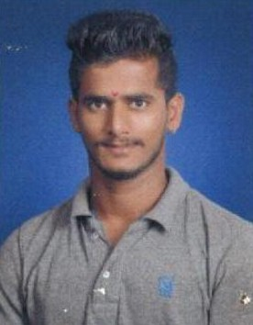

Vijaysingh Yadav College Men Hockey team is Winner in Shivaji University Inter zonal Men Hockey Tournament.
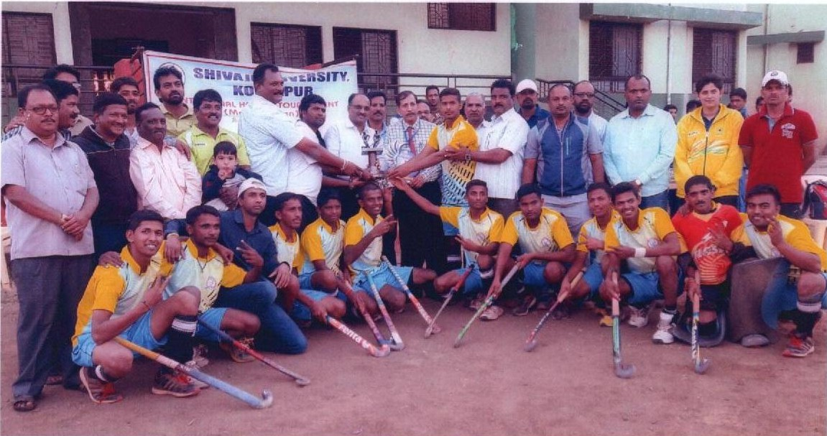

Vijaysingh Yadav College Women Hockey team get Fourth place in Shivaji University inter zonal women Hockey tournament.
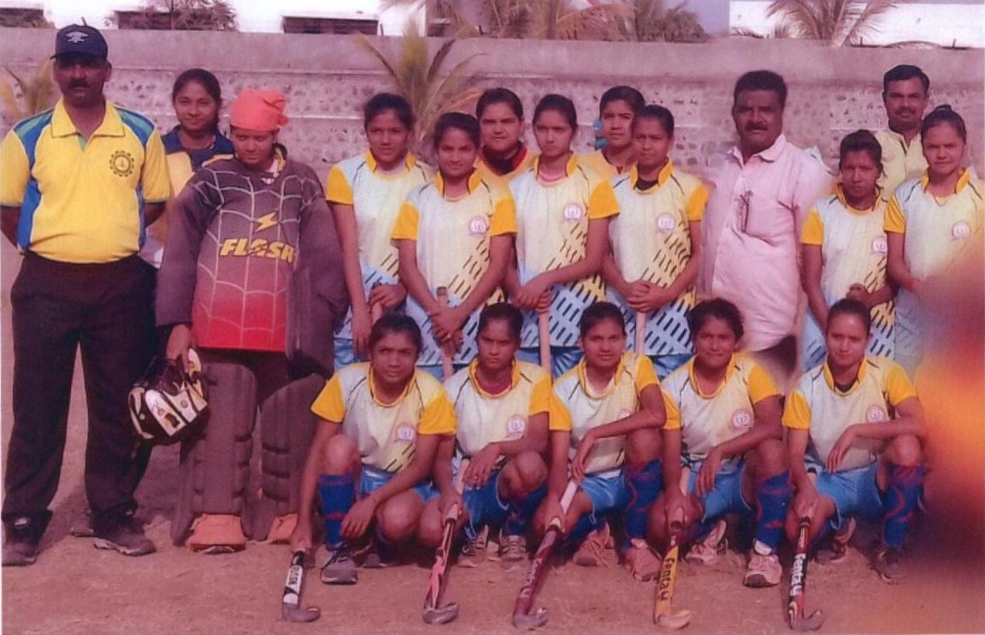

Consistent Four year women Kho-Kho champion team in zonal
Kho-Kho competition.
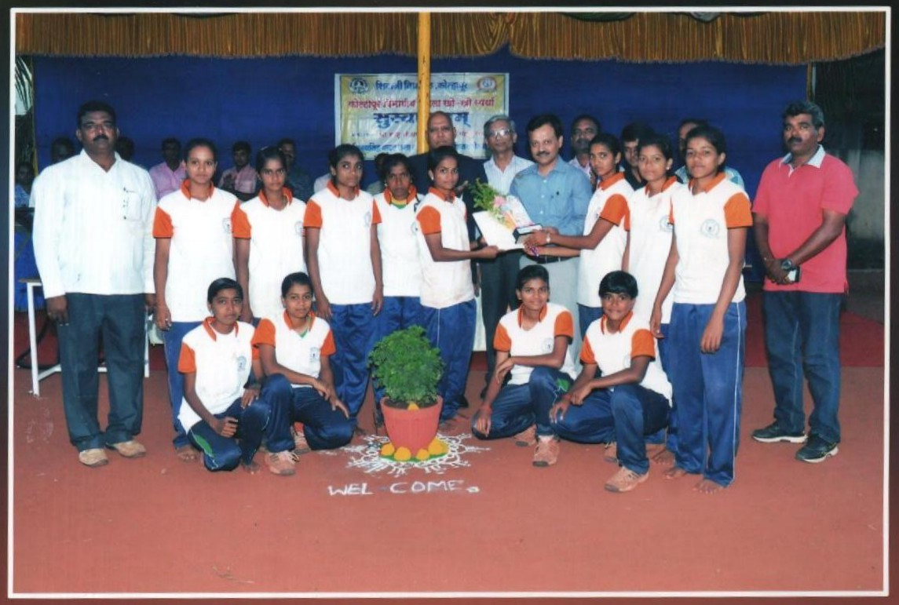

College has organized Kho-Kho Women Zonal competition in the college.
