Shri Vijaysinha Yadav Arts And Science College, Peth Vadgaon
Department of Sports
Report - 2017-2018
1) | Mayur Sudhir Rokade, B.Sc. Selected in Shivaji University Team for All India Inter University Level Archery Competition - Personal Recurve Round Got Siliver Medal. | 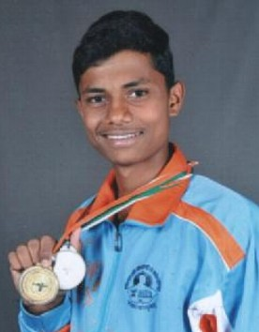
2) | Abhinandan Ravindra Wadkar, B.Sc. II is selected in Shivaji University team for All India Inter University Level Archery Competition Team event Recurve Round Got Silver Medal. | 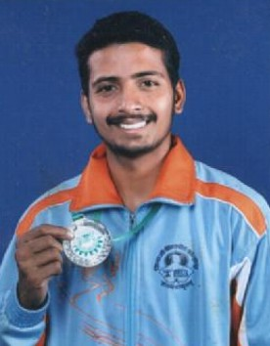
3) | Vivek Manohar Parit, B.Sc. II is selected in Shivaji University team for All India Inter University Level Archery competition Team event Recurve Round Got Siliver Medal. | 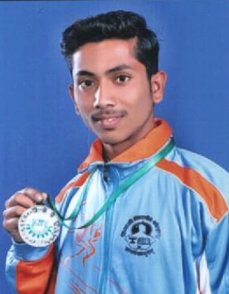
4) | Shubham Shivaji Sutar, B.A. II selected in Shivaji University Men Hockey team got Gold medal to nest Zoye participated in All India inter University Competition. | 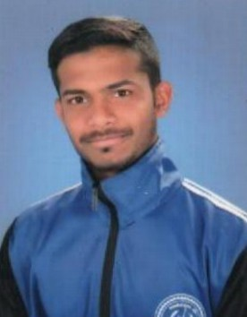
5) | Rohan Rajaram Powar, B.A. II selected in Shivaji University Men Hockey team got Gold medal to nest Zoye participated in All India inter University Competition. | 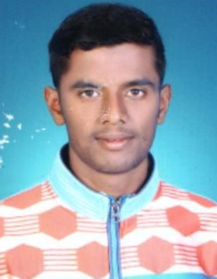
6) | Saurabh Bhimrao Sutar, B.A. II selected in Shivaji University Men Hockey team got Gold medal to nest Zoye participated in All India inter University Competition. | 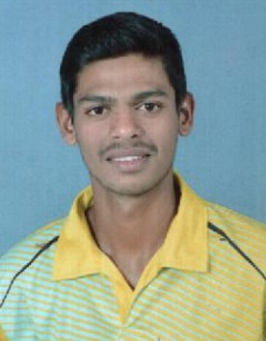
7) | Padmraj Prashant Shinde, B.A. II selected in Shivaji University Men Hockey team got Gold medal to nest Zoye participated in All India inter University Competition. | 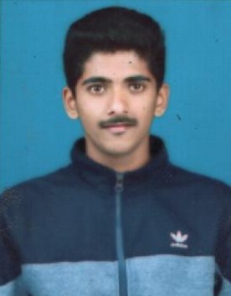
8) | Miss. Vidula Milind Patil, B.Sc.-II selected in Women Hockey Team of Shivaji University got Fourth number in nest zone inter University competition participation in All India inter University competition. | 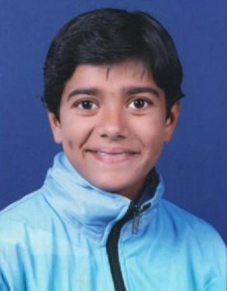
9) | Miss. Snehal Popatrao Wakse, B.Sc.-II selected in Women Hockey Team of Shivaji University got Fourth number in nest zone inter University competition participation in All India inter University competition. | 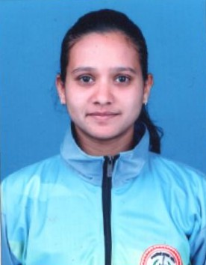
10) | Miss. Anushka Rajendra Bhosale, B.Sc.-II selected in Women Hockey Team of Shivaji University got Fourth number in nest zone inter University competition participation in All India inter University competition. | 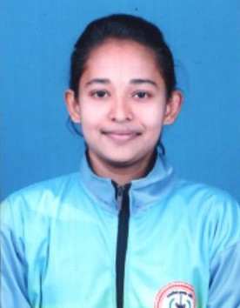
11) | Miss. Gayatri Vijay Ingalkar, B.Sc.-II selected in Women Hockey Team of Shivaji University got Fourth number in nest zone inter University competition participation in All India inter University competition. | 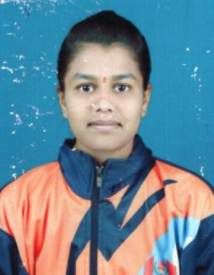
12) | Miss. Arpana Gangaram Patil, B.Sc.-II selected in Women Hockey Team of Shivaji University got Fourth number in nest zone inter University competition participation in All India inter University competition. | 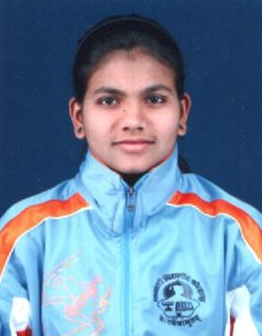
13) | Miss. Laxmi Jayram Patne, B.Sc.-II selected in Combied Practice Camp Kho-Kho women team in Shivaji University Team. | 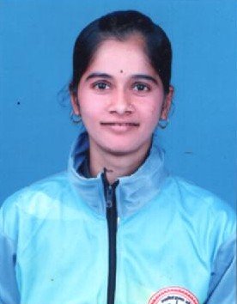
14) | Vaibhav Krushnath Raskar, B.A.-II selected in Shivaji University Judo Men Team. | 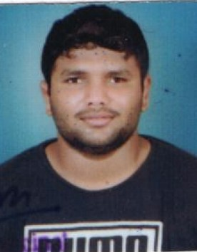
15) | Miss. Ankush Ishwar Mane, B.A.-II got Silver Medal in 79 Kg wrestling Maharashtra Kesari Wrestling Competition. | 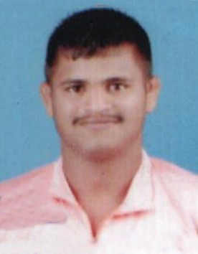
16) | Anil Kondiba Kachare, B.A.-II got Silver Medal in 92 Kg wrestling Maharashtra Kesari wrestling competition. | 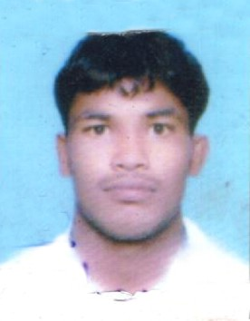
17) | Saurabh Aabasaheb Tamkhade, B.A.-I got "Maharashtra Yuva Kesari" in 62 Kg wrestling competition. | 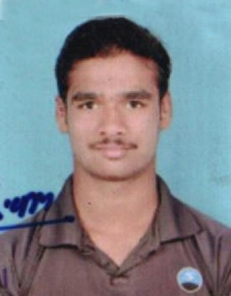
18) | Miss. Poonam Vishwas Gavad, B.A.-II she is selected as Captain of Maharashtra state Senior Women Hockey Team. | 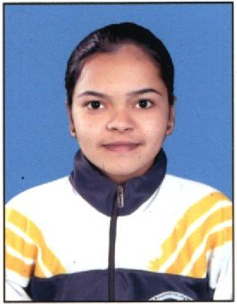

Vijaysingh Yadav College Men Hockey team got Shivaji University Interzonal Men Hockey Tournament runner up.
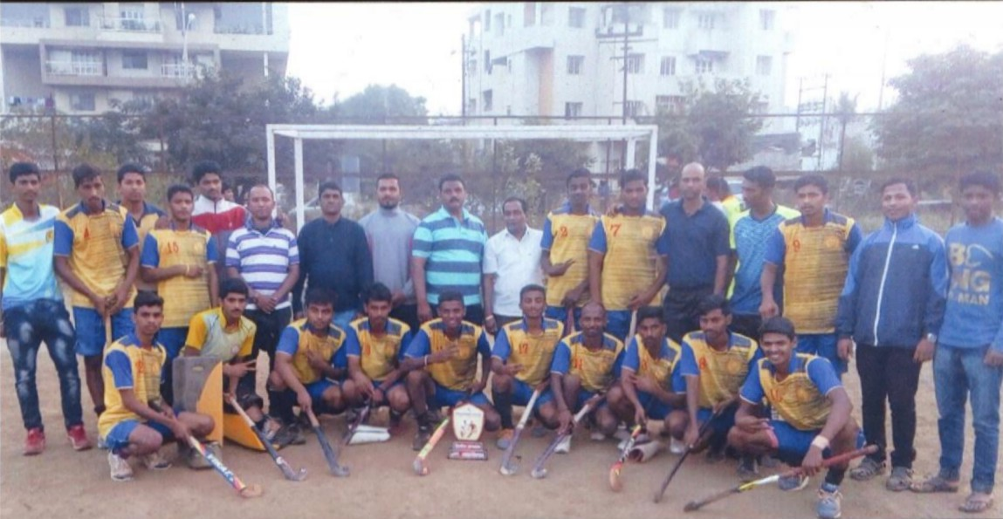

Vijaysingh Yadav College Women Hockey team get third place in Shivaji University interzonal women Hockey tournament.
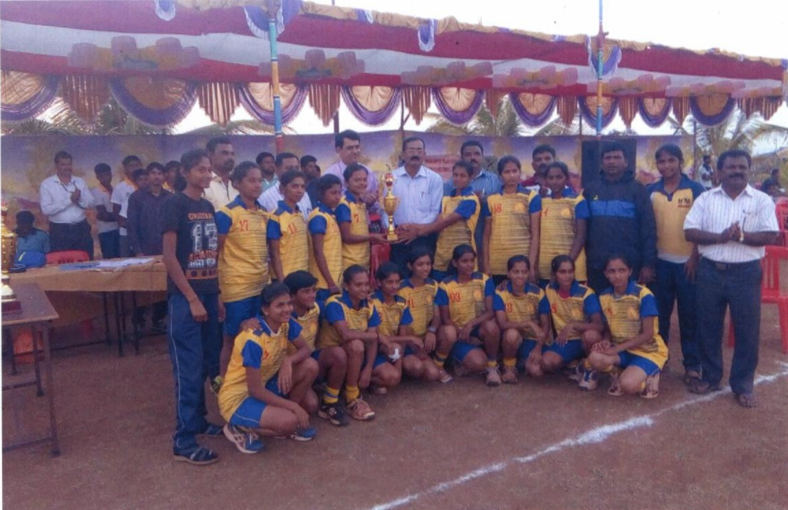

College has organized Shivaji University inter-zonal Archeary Men and Women competition in the college dated 29th and 30th November 2017.
