Shri Vijaysinha Yadav Arts and Science College, Peth Vadgaon
Department of Sports
Report 2018-2019

This academic year also students continues the bright tradition of success good number of players and teams participated in University Level, Inter-zonal Level and Zonal Level sports competitions and tournaments. The important events they participated are –
- Boxing : Men and Women
- Kabaddi : Men
- Archery : Men
- Wrestling : Men (Free Style)
- Wrestling : Men (Greco Roman)
- Judo : Men
- Taekwondo : Men and Women
- Hockey : Men and Women
The participates of our college achieved glittering success in following competitions/tournaments-
A achievements in Kolhapur Zonal Tournaments
I) Boxing (Men) :- One Gold and One Silver.
1) Shinde Omkar Prashant :- Gold
2) More Tanmay Pravin :- Silver
II) Kabaddi Men Team Participation
III) Wrestling Men (Free Style) – Three Gold Medal Two Silver One Bronze Medal
"General Champioship free style wrestling competition."

- Kisave Dnyaneshwar Balu :- Gold 125 Kg Weight
- Mane Bhairu Kisan :- Gold 86 Kg Weight
- Tamkhade Sourabh Abasaheb :- Gold 70 Kg Weight
- Thorat Harshawardhan Sanjay :- Silver 97 Kg Weight
- Patil Vaibhav Balasaheb :- Silver 70 Kg Weight
- Raskar Vaibhav Krushnat :- Bronze 97 Kg Weight

IV) Wrestling Men (Greco Roman) – Two Gold and Four Silver Medal
"General Champioship Greco Roman wrestling competition."
- Mulani Jamir Bashir :- Gold 87 Kg Weight
- Madane Amar Mahadev :- Gold 72 Kg Weight
- Chougule Bapu Baban :- Silver 77 Kg Weight
- Mane Ankush Ishwar :- Silver 82 Kg Weight
- Salunkhe Sangram Dhanaji :- Silver 97 Kg Weight
- Patil Ranjit Arjun :- Silver 72 Kg Weight

V) Taekwondo Men and Women – One Gold and Two Silver Medal
- Miss Waghmode Jyoti Sayaji :- Gold 73 Kg Weight
- Miss Autade Pragati Prabhakar :- Silver 49 Kg Weight
- Mr. Vathare Akshay Appaso :- Silver 67 Kg Weight

Shivaji University Inter-Zonal Tournament
I) Hockey Women Team – Winner
II) Hockey Men Team – Runner-up
III) Judo Men – Two Gold Medal Two Silver Medal
- Salunkhe Sangram Dhanaji :- Gold 100 Kg Weight
- Nikam Tushar Dhanaji :- Gold 78 Kg Weight
- Kisave Dnyaneshwar Balu :- Silver 100+ Kg Weight
- Mane Ankush Ishwar :- Silver 81 Kg Weight

IV) Wrestling Men (Free Style) – Three Gold, Two Silver and One Bronze Medal
"General Champioship Free Style Wrestling Tournament."
- Kisave Dnyaneshwar Balu :- Gold
- Mane Bhairu Kisan :- Gold
- Raskar Vaibhav Krushant :- Gold
- Tamkhade Sourabh Abasaheb :- Silver
- :- Silver
- Patil Vaibhav Balasaheb :- Bronze

IV) Wrestling Men (Greco Roman) – One Gold Medal
- Mane Ankush Ishwar :- Gold

V) Taekwondo Men and Women Tournament – One Silver, One Bronze Medal
- Miss. Waghmode Jyoti Sayaji :- Silver 73+ Kg Weight
- Vathare Akshay Appaso :- Bronze 67 kg Weight

VI) Archery Men :- One Gold and One Silver One Bronze Recurve Round
- Rokade Mayur Sudhir :- Gold
- Parit Vivek Manohar :- Silver
- Wadkar Abhinandan Ravindra :- Bronze

Shivaji University Selection for Team event and Indual event
West Zone Inter University and All India Inter-University Tournament.
- Hockey Men:- 1) Powar Rohan Rajaram – University Team Captain.
2) Sutar Shubham Shivaji
3) Udale Akash Prakash
- Hockey Women :- West Zone Inter University Tournament
- Gavad Poonam Vishwas
- Patil Vidula Milind
- Patil Susmita Sanjay
- Bhosale Anushka Rajendra
- Jadhav Siddhi Sandip
- Wakase Snehal Popatrao

- Judo Men :- All India Inter University Tournament
- Salunkhe Sangram Dhanaji.
- Nikam Tushar Dhanaji.

- Wrestling Men (Free Style) :- All India Inter University Competition.
- Kisave Dhyaneshwar Balu.
- Raskar Vaibhav Krushnat.
- Mane Bhairu Kisan : Gold

- Wrestling Men (Greco Roman) :- All India Inter University Competition.
- Mane Ankush Ishwar.

- Archery Men:- All India Inter University Tournament.
- Rokade Mayur Sudhir.
- Parit Vivek Manohar.
- Wadkar Abhinandan Ravindra.

Achievement in Maharashtra Kesari Wrestling Men Tournament- 2018
- Thorat Harshvardhan Sanjay – Selected in 97Kg weight category.
- Mulani Jamir Basir – Selected in 86 Kg Weight category.
Outstanding Achievement :-
Hockey Women – selected in Kelo India Hockey Women Maharashtra Team.
- Miss. Patil Vidula Milind.
- Miss. Gavad Poonam Vishwas.

Archery Men (Fita) selected in Maharashtra State Team Kelo India Tournament – Archery men yuth India – selected in India Camp.
- Rokade Mayur Sudhir.

Selected in 45th Six A Side Indoor Men International Hockey Tournament at Malyseia.
- Shinde Padmaraj Prashant.

All India Inter University Men Free Style Wrestling Tournament 86Kg. weight category Gold Medalist.
- Mane Bhairu Kisan.

All India Inter University Men Recurve Round Archery Tournament – Bronze Medal Players –
- Rokade Mayur Sudhir.
- Parit Vivek Manohar.
- Wadkar Abhinandan Ravindra.

Organized Events:
- College successfully organized Shivaji University Inter Zonal Men and Women Archery Tournament on 11th and 12th Sept. 2018 the Maugazation function was graced by Mr. Dr. Sardar Jadhav, Director Cyrus Poonawala International School, Peth Vadgaon and Principal Dr. Vijaya Chavan, Presided the function.
For the valedichery function Prin. M. A. Parit secretory, Adarsh Education Institute were chief guest.
Total ……20 colleges from the Shivaji University and total 130 players participated in the tournament.
- College successfully organized Shivaji University Inter-Zonal Women Hand Ball Tournament on 10, 11 Oct. 2018 the Maugazatio function was graced by Principal Vijaya Chavan and Valedichery function. Total 09 colleges from the Shivaji University territory and total 108 players participated in the tournament.

Shri Vijaysinha Yadav Arts and Science College, Peth Vadgaon
Department of Sports
Report 2018-2019

Rokade Mayur Sudhir B.A. I selected for Shivaji University Team of All India Inter University Level Competition, Kelo India and Yuth India Practice Camp.
(Bronze Medal)

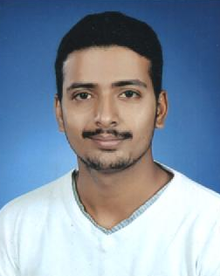
Wadkar Abhinandan Ravindra B.Sc. III is selected in Shivaji University team for All India Inter University Competition.
(Bronze Medal)

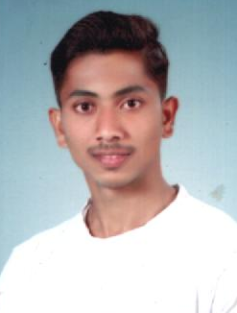

Parit Vivek Manohar B.Sc. II is selected in Shivaji University team for All India Inter University Competition.
(Bronze Medal)

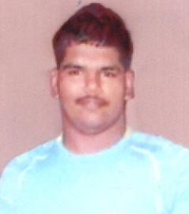

Salunkhe Sangram Dhanaji B.A.II is selected for Judo 100Kg. in Shivaji University team for All India Inter University Competition.

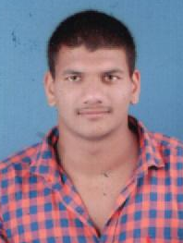

Nikam Tushar Dhanaji B.A.II is selected for Judo 78Kg. in Shivaji University team for All India Inter University Competition.

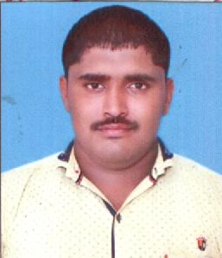

Kisave Dnyaneshwar Balu B.A.III is selected for wrestling free style 125Kg. weight in Shivaji University team for All India Inter University Competition.

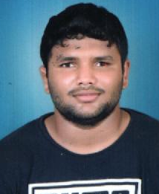

Raskar Vaibhav Krushnat B.A.II is selected for wrestling free style 97Kg. weight in Shivaji University team for All India Inter University Competition.

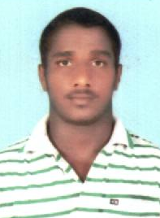
Mane Bhairu Kisan B.A.II is selected for wrestling free style 92Kg. weight in Shivaji University team for All India Inter University Competition and got Gold Medal.

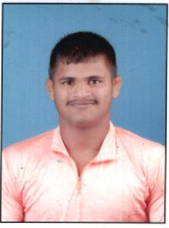

Mane Ankush Ishwar B.A.II is selected for wrestling free style 82Kg. weight in Shivaji University team for All India Inter University Competition.

Thorat Harshavardhan Sanjay is selected Maharashtra Kesari Wrestling (97Kg Weight) competition, got silver medal in this competiton.

Shinde Padmaraj Parshant is selected for 45 Six A side Indoor Men International Hockey Competition at Malyseia.

Mulani Jamir Bashir is selected for Maharashtra Kesari Wrestling Competition in 86Kg.

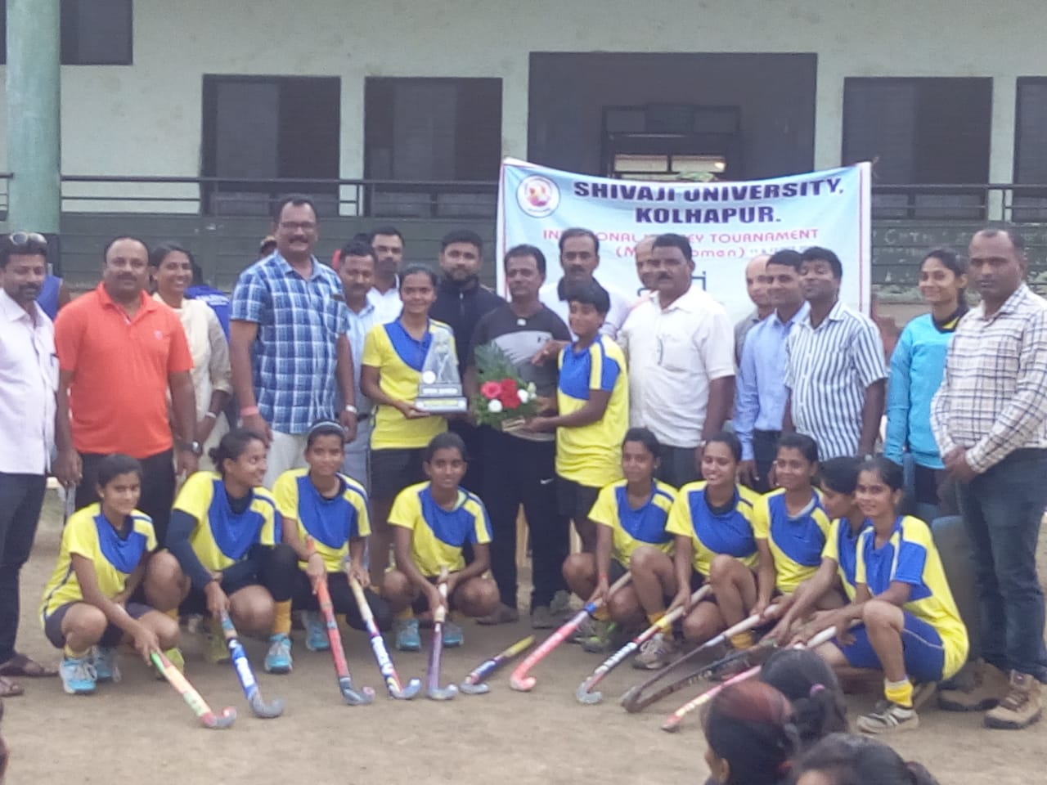
Shivaji University Inter Zonal Women Hockey First Winner Team of College.
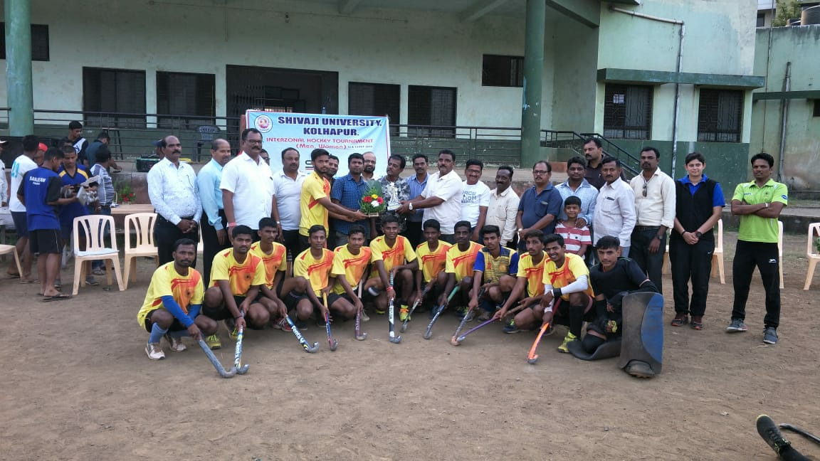
Shivaji University Inter Zonal Men Hockey Team – Runner up.
Shivaji University Inter Zonal Men and Women Archery Competition.

Organization of Inter Zonal Women Hand Ball Competition.
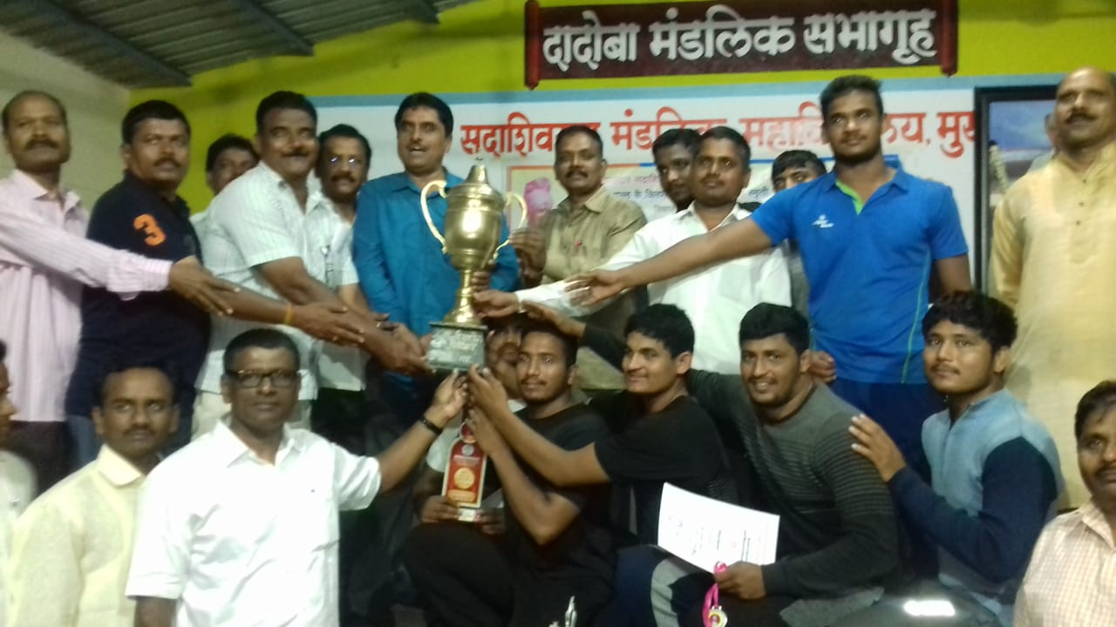

Kolhapur Zonal Wrestling Free Style Men Competition General Championship.

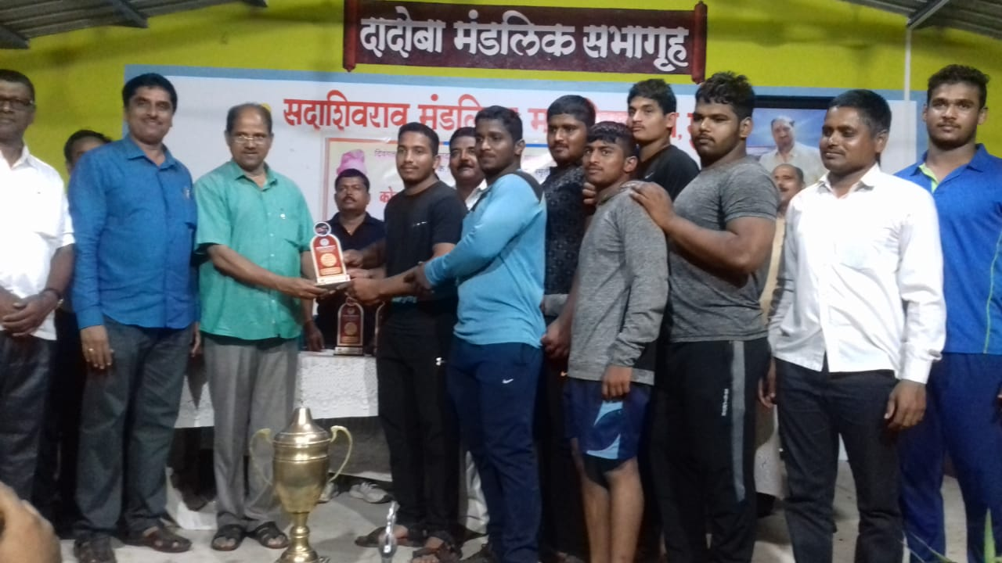
Kolhapur Zonal Wrestling Greco Roman Men Competition General Championship.
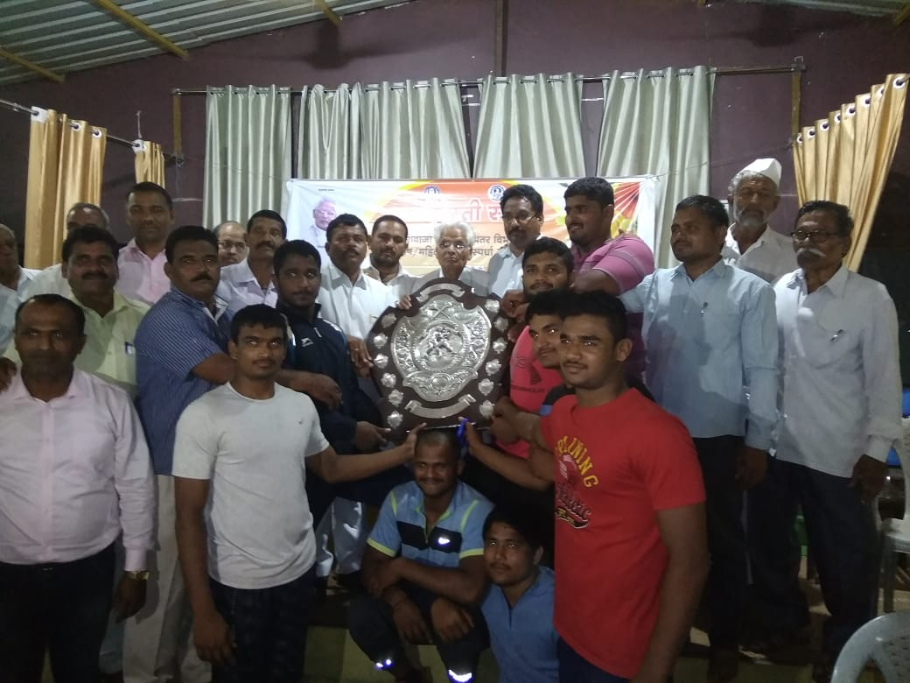
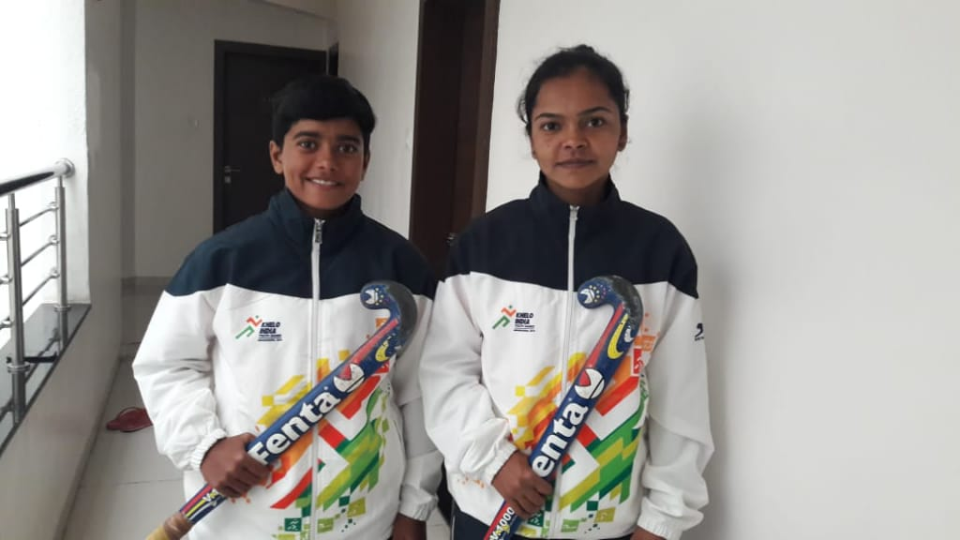
Shivaji University Inter Zonal Men Wrestling free style General Championship.

Selected for Khelo India Hockey Women Tournament.
Powar Rohan Rajaram, Sutar Shubham Shivaji and Udale Akash Prakash are selected as Shivaji University Men Hockey Team Captain and Members.

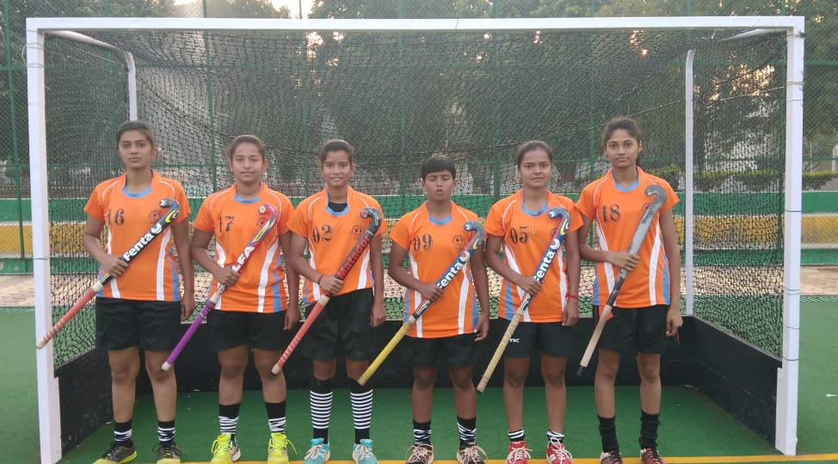

Gavad Poonam Vishwas, Patil Vidula Milind, Patil Susmita Sanjay, Bhosale Anushka Rajendra, Jadhav Siddhi Sandip and Wakase Snehal Popatrao selected in Shivaji University Women Hockey Team.

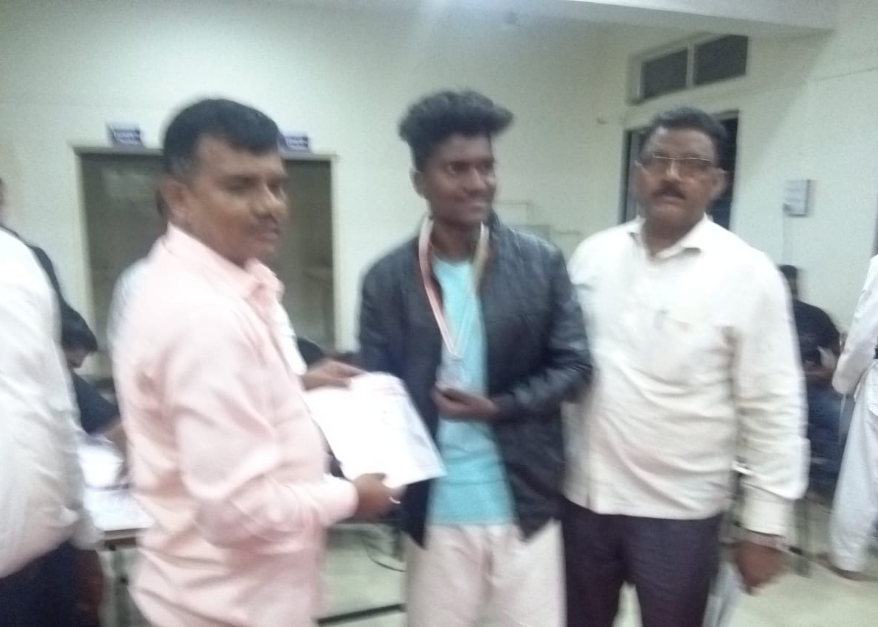
Shivaji University Inter Zonal Men Taekwondo Competition (Bronze Medal).
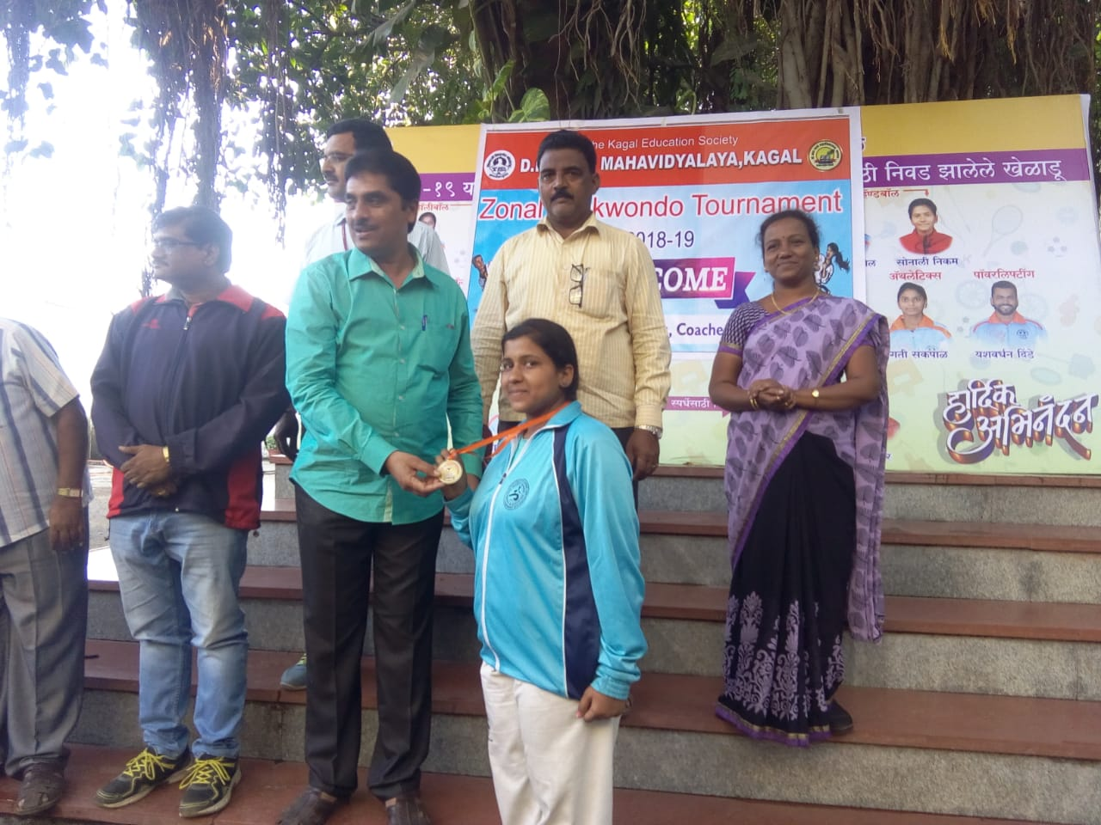

Shivaji University Inter Zonal Women Taekwondo Competition (Silver Medal).

