Avishkar Competition
Title:Avishkar Competition
Venue :Dr. J. J. Magdum College of Engineering, Jaysingpur.
Date :28th December, 2017
Time:11.00 am to 5.00 pm.
Details of the Event:
On 28th Dec.2017,eight students were participated in district level inter college Avishkar Poster / Model Research competition organized by Dr. J. J. Magdum College of Engineering, Jaysingpur in Four different categories.
Sr.No. | Name of the Students | Category
1 | Miss. Khurd Arati Sunil | Pure Science
2 | Mr. Fadtare Rushikesh Sarjerao | Pure Science
3 | Mr. Mohite Akshay Tanaji | Engineering and Technology
4 | Miss. Jagtap Monika | Engineering and Technology
5 | Miss. Pawar Sonali Tanaji | Agriculture & Animal Husbandry
6 | Miss. Garaje Renuka Rajendra | Agriculture & Animal Husbandry
7 | Miss. Patil Ruchita Vilas | Pharmacy & Medicine
8 | Miss. More Mayuri Ananda | Pharmacy & Medicine
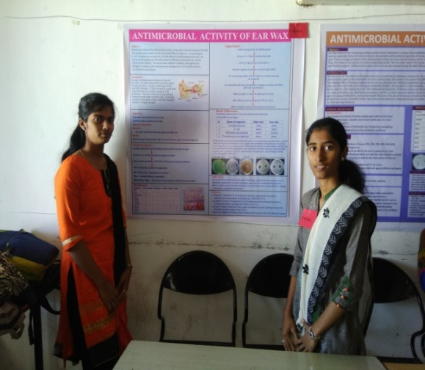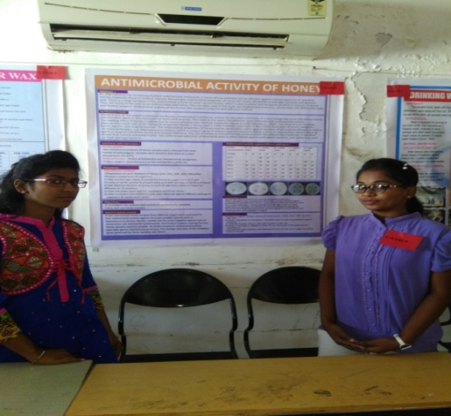

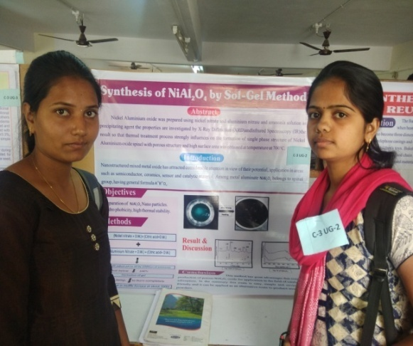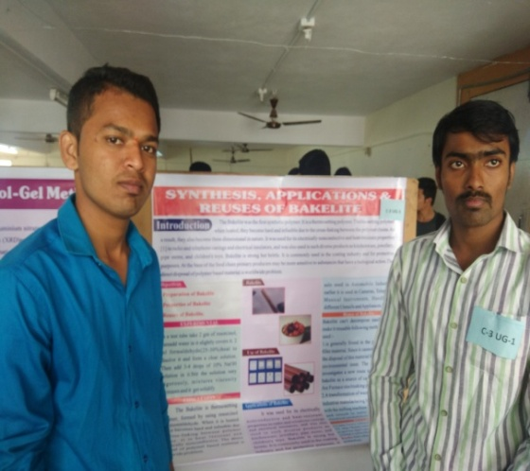
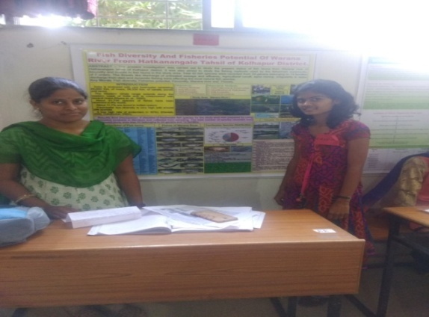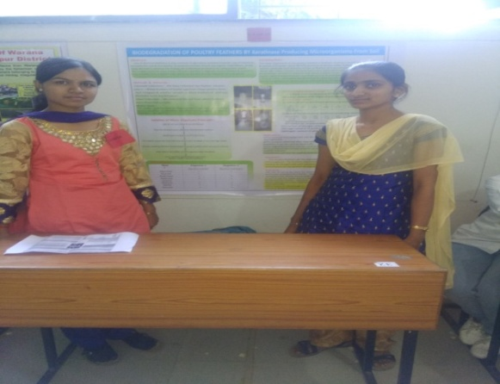

Coordinator Principal

