Pre Avishkar Competition
Title:Pre Avishkar Competition
Chief Guest: Dr. S. V. Pore, BoS, Chemistry
Dr. V. V. Killedar, BoS, Physics
President:Dr. B. S. Jadhav, BoS, Geography
Venue :College Seminar Hall and Room No. 43
Date : 4th December, 2017
Time: 11.00 am to 05.00 pm.
Details of the Event:
On 4th Dec.2017, Seventy Four students in 31 groups were participated in intra college Avishkar Poster / Model Research competition organized by Shri. Vijaysinha Yadav Arts and Science College, Peth Vadgaon. The competition was held in four different categories like Pure Science, Agriculture & Animal Husbandry, Pharmacy & Medicine and Engineering and Technology. The participants got First and Second ranks are selected for district level Avishkar Competition.
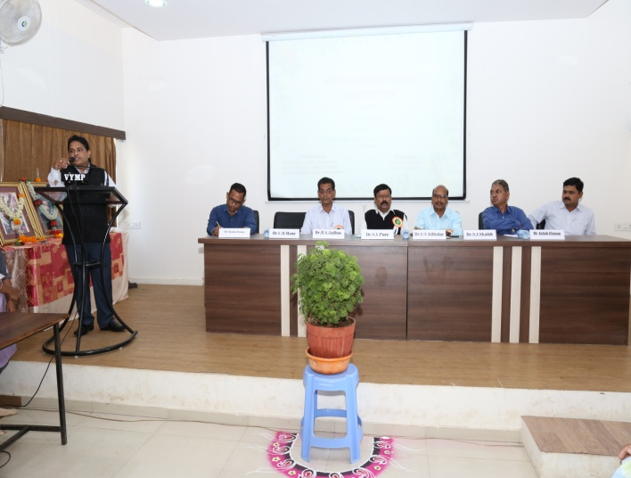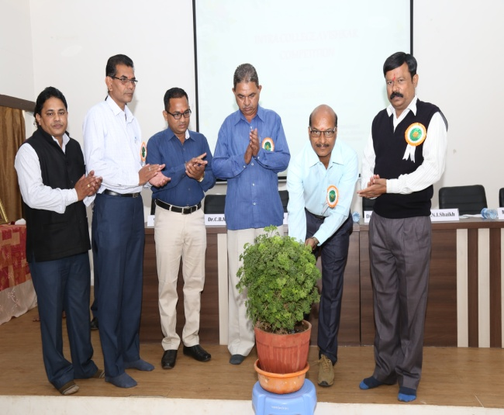
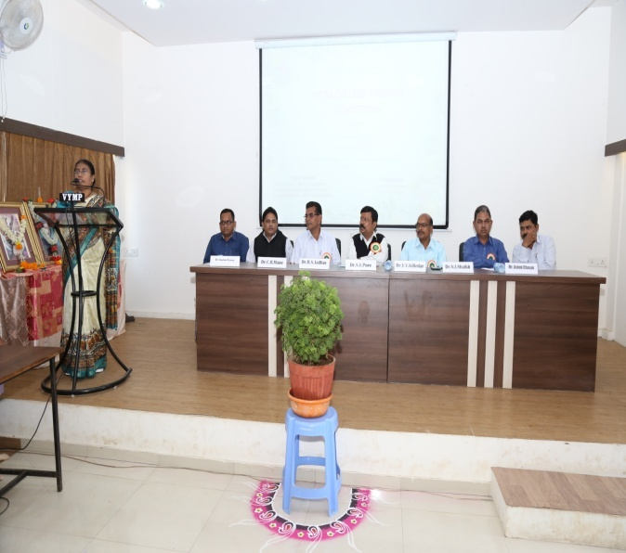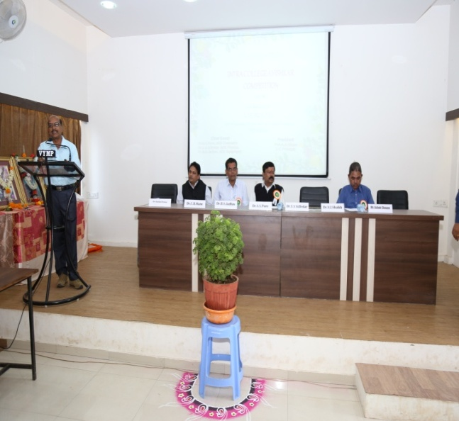
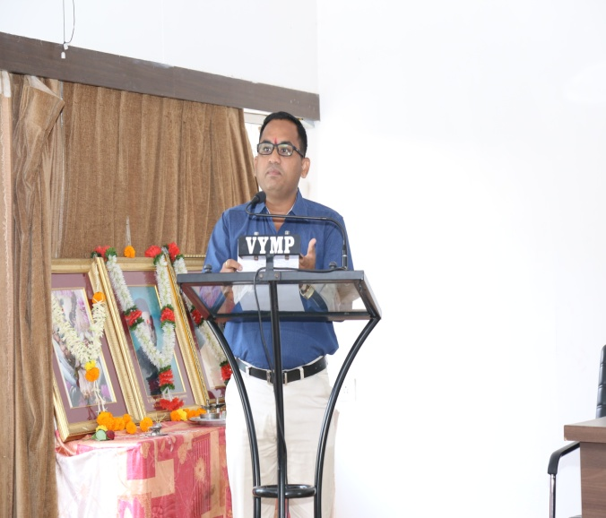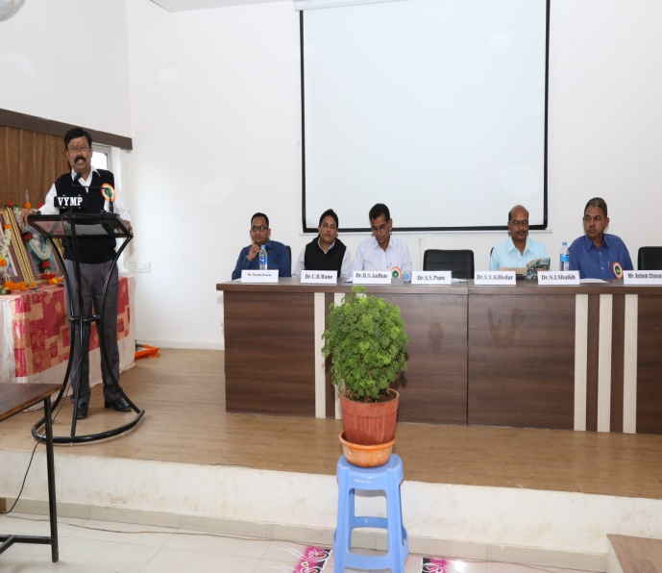
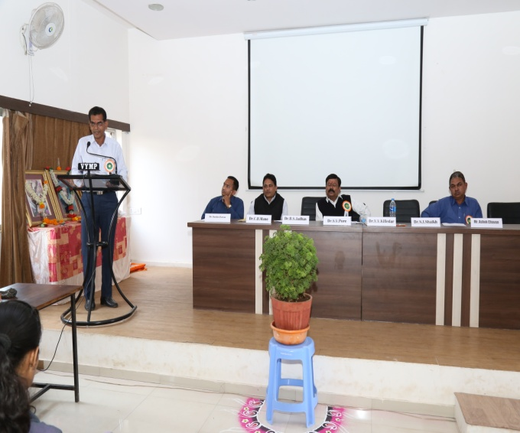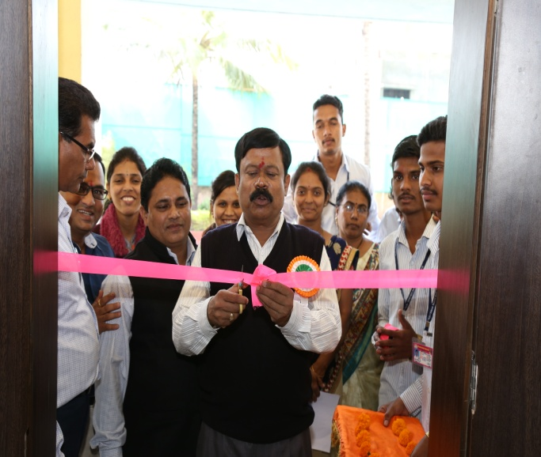
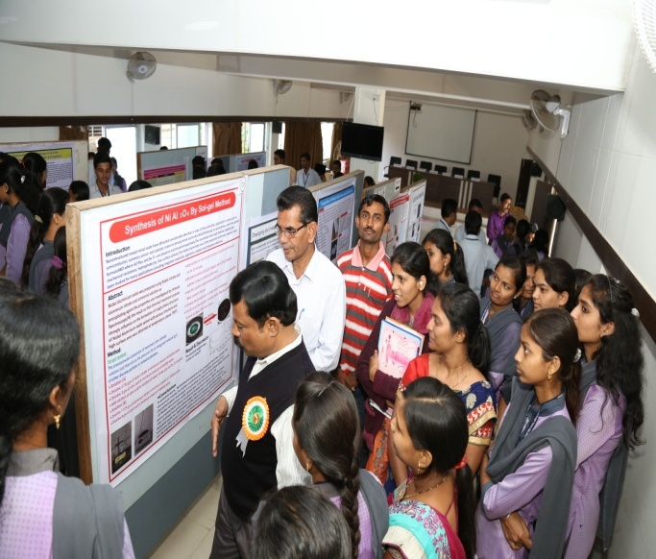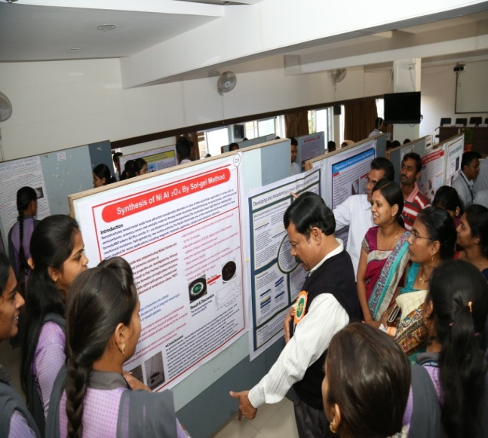
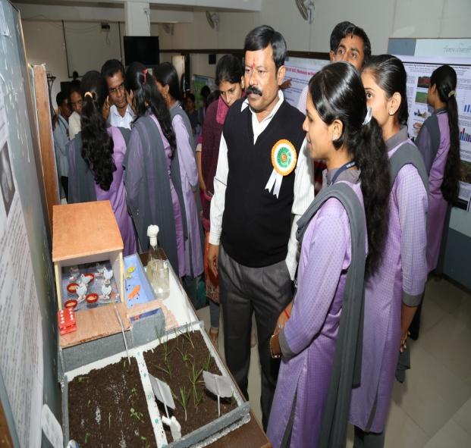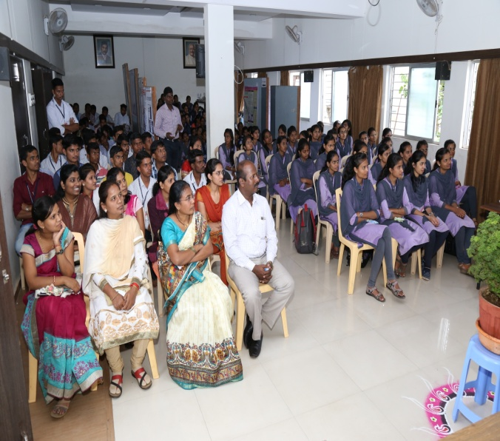

Coordinator Principal

