Research Cell- 2018-19
Title: Research Project Proposal Presentation
President: Dr. Vijaya Chavan
Venue: College Seminar Hall
Date: Saturday, 22nd September, 2018
Time: 11.00 am to 04.00 pm.
Details of the Event: The College has established Rs. 1, 00,000/- (One Lakh Rupees only) fund for promoting research activities among the students and faculty members. It is decided that the fund will be used in the following manner for the next five years.
Sr. No. | Activity | Number | Amount | Total Amount
01 | Students Research Project | 02 | 5000/- | 10000/-
02 | Faculty Research Project | 01 | 5000/- | 5000/-
03 | Faculty Research Paper Publication | 05 | 1000/- | 5000
04 | Publication of Reference Book | 03 | 1000/- | 3000/-
Proposals from the interested faculty members and students were invited. Total 15 students and 03 faculty members submitted their proposals for financial assistance. The research cell organized presentations of these proposals for the selection to provide financial assistance. following faculty members worked as examiners:
Chairman: Dr. Vijaya R. Chavan
Members: Dr. Prashant P. Yadav, Dr. Balasaheb S. Jadhav,
Prof. Renuka A. Pawar, Dr. Sachin J. Pawar.
Out of these research projects, following projects were selected for financial assistance for the academic year 2018-19.
Sr. No. | Department | Name of Guide | Faculty / Students | Title of Project | Level | Amount Sanctioned
01 | Botany | Mr Jagtap. D. G. | Dr. Santosh S. Bhosale (Faculty Member) | Establishment of VIJAY herbarium in Department of Botany- A constructive Approach | College | Rs. 5000.00
02 | Geography | Dr. Jadhav B. S. | Miss. Patel Jyoti Suresh  Miss. Patil Supriya Bajirao  Miss. Tawandkar Pranoti Anil  Mr. Khot Akshay Ashok | Geographical Analysis of Soil Health : A Case Study of Latawade Village in Hatkanangale Tahasil ( Kolhapur District) | College | Rs. 5000.00
03 | Microbiology | Mrs. Suryawanshi P. | Mr. Jadhav Shubham Shivaji  Mr. Kamble Prajval Rajendra  Mr. Patole Ajay jaysing  Mr. Mulla Nadim Munsur | Production of Bio-fertilizer to Enhance Soil Fertility | College | Rs. 3000.00

The work of research projects is going on. The final submission date of the research projects is 30th April, 2019.
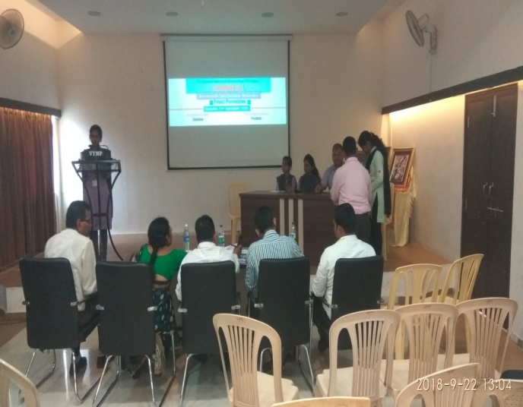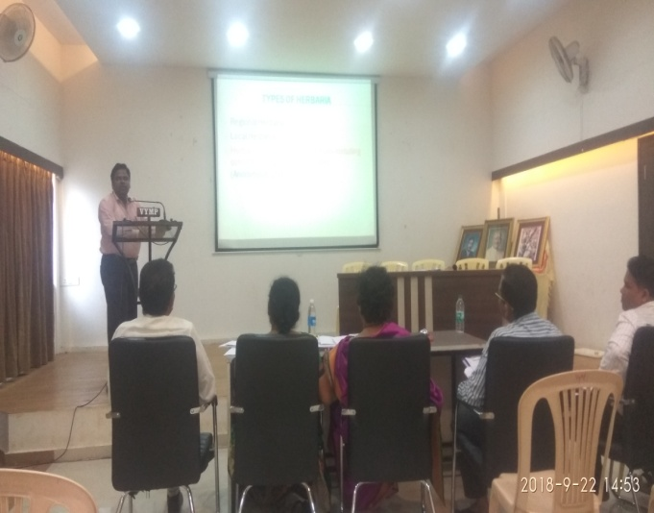

Chairman, Principal,
Research Cell

