Shivaji University District Level Avishkar Competition.

Title: Shivaji University District Level Avishkar Competition.
Chief Guests: 1. Dr. Bharati Patil, Dean, Social Science Faculty,
Shivaji University, Kolhapur
President: Dr. A. M. Gurav, Coordinator, Avishkar Competition,
Shivaji University, Kolhapur
In Presence of: Dr. Vijaya Chavan, Principal,
Shri. Vijaysinha Yadav Arts and Science College, Peth Vadgaon
Coordinator: Dr. C. B. Mane
Venue: Inauguration: College Seminar Hall
Competitions: Class Rooms and Labs
Date: Thursday, 27th December, 2018
Time: 09.00 am to 06.00 pm.

It is a moment of pride for the Research Cell that the cell organized District Level Avishkar Competition of Shivaji University, Kolhapur on 27th December, 2018. Total 276 participants from 45 different colleges presented their research related posters and models in the six categories of Avishkar Competition.
Prof. Dr. Bharati Patil, Dean, Social Science Faculty, Shivaji University, Kolhapur was the Chief Guest for the inauguration function of the competition. Dr. A. M. Gurav, Coordinator, Avishkar, Shivaji University, Kolhapur, and Prof. Prashant Anabule were also present for the inauguration function. Prin. Dr. Vijaya Chavan chaired the function. Dr. C. B. Mane worked as coordinator of the competition.
The posters and models were examined by the respective examiners in the various categories. For the he prize distribution ceremony, Mr. Rajkumar Pol, Member of Managing Body of institute was the Chief Guest. Total eighteen prizes in six categories were given in the function.
All the faculty members of the college worked sincerely for the grand success of the Avishkar Competition.
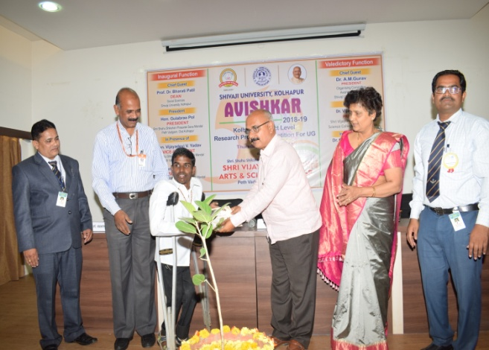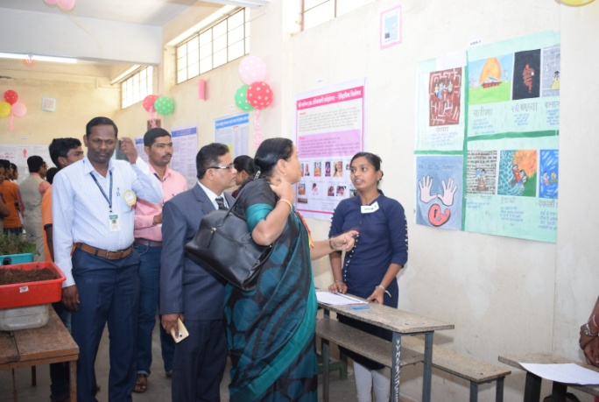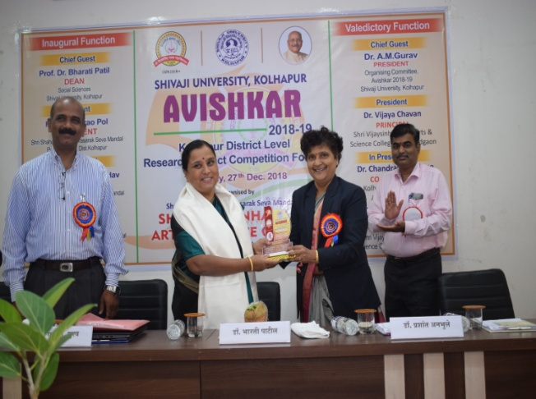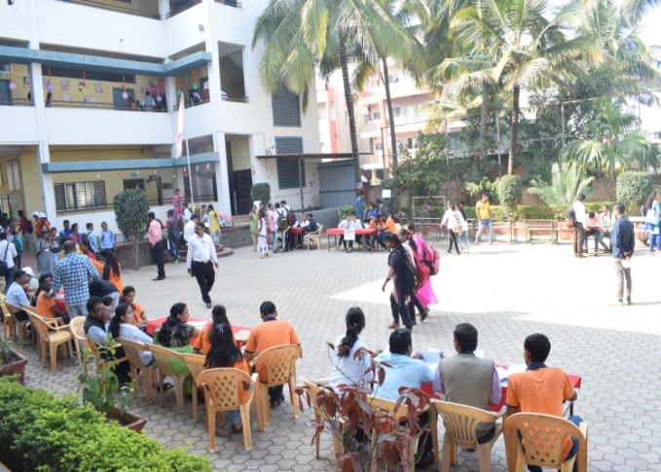

Chairman, Principal,
Research Cell

